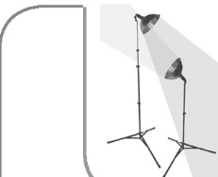
APPLICATION FOR A MENTOR

Name: _____________________
Date: _______

Address, City, Zip: _____________________________

EmaiI: _____________________ Date of Birth: _______

Phone (home): _____________ (cell): _______________

Parent/Guardian Name(s): ___________________________ School Attending: _______________________ Grade: ____

Are you a Christian? Yes, I'm sure No Not sure Gender: M F

List 3 people (same gender as you) that you would like us to consider as a mentor for you

1. ___________________

2. ______________________________________

3. ______________________________________

What school or community activities do you participate in? _____________

______________________________________

______________________________________

What do you do for fun (Hobbies, Interests)? _______________________________________

___________________________________________________________________________

____________________________________________________________________________

I give my permission for my child to enter into a mentoring relationship with one of the above three people I have listed as preferred mentors.

Parent Signature:____________________________________________Date:______________

MENTORING FROM START TO FINISH

